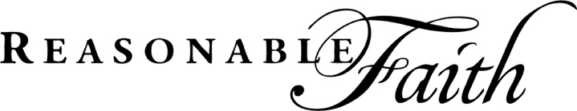

Employer Gift Match – Double Your Donation!
Many companies offer matching gift programs to encourage employees to contribute to charitable organizations. Some provide matching funds to support employee volunteer hours. Most of these programs match contributions dollar for dollar, and some will even double or triple the amount of your gift! Go to Charity Navigator to see if your company currently participates in a matching program. Here is a list of companies that currently are active:
- Aetna
- AT&T
- Bank of America
- Boeing
- BP
- British Petroleum
- CarMax
- Coca-Cola
- Dell
- ExxonMobil
- Ford
- Gap Corporation
- General Electric
- IBM
- Johnson & Johnson
- Lockheed-Martin
- McDonald’s
- Merck & Co.
- Microsoft
- PepsiCo
- Pfizer
- Soros Fund Management
- State Street Corporation
- Target Corp.
- Verizon Communications
- Walt Disney Corporation
- Wells Fargo

